The wave that eats people

The Japanese word ‘tsunami’, though almost universally accepted as the name for what happened on December 26th, 2004, is not completely accurate in describing the disaster. ‘Tsunami’ literally means ‘harbour wave’; however, it is clear from the scale of the tragedy that it occurred wherever the waves hit – not just in harbours.

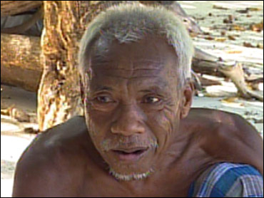
Andaman Sea Gypsies, or Moken, some of whom live in the Phi Phi sea area, have a centuries-old traditional word for a wave of almost unimaginable force:

Laboon literally means ‘the wave that eats people’.

Moken tribal elders have described seeing signs of a forthcoming laboon several days before December’s catastrophe: cicadas stopped chirping; entire shoals of fish jumped from the water; deep sea creatures were seen at the surface; several elders described receiving visits from ancestors in their dreams, warning them of impending horror coming from the sea.

Whether these claims are true or not, we may never know. However, it is clear that entire tribes of Moken managed to save themselves from the waves by getting to high ground swiftly: Moken tradition tells that if the sea recedes rapidly, a laboon is coming fast.

